1. **Create html file**

**4 input boxes**

**- Name**

**- Age**

**- Qualification**

**- Submit button**

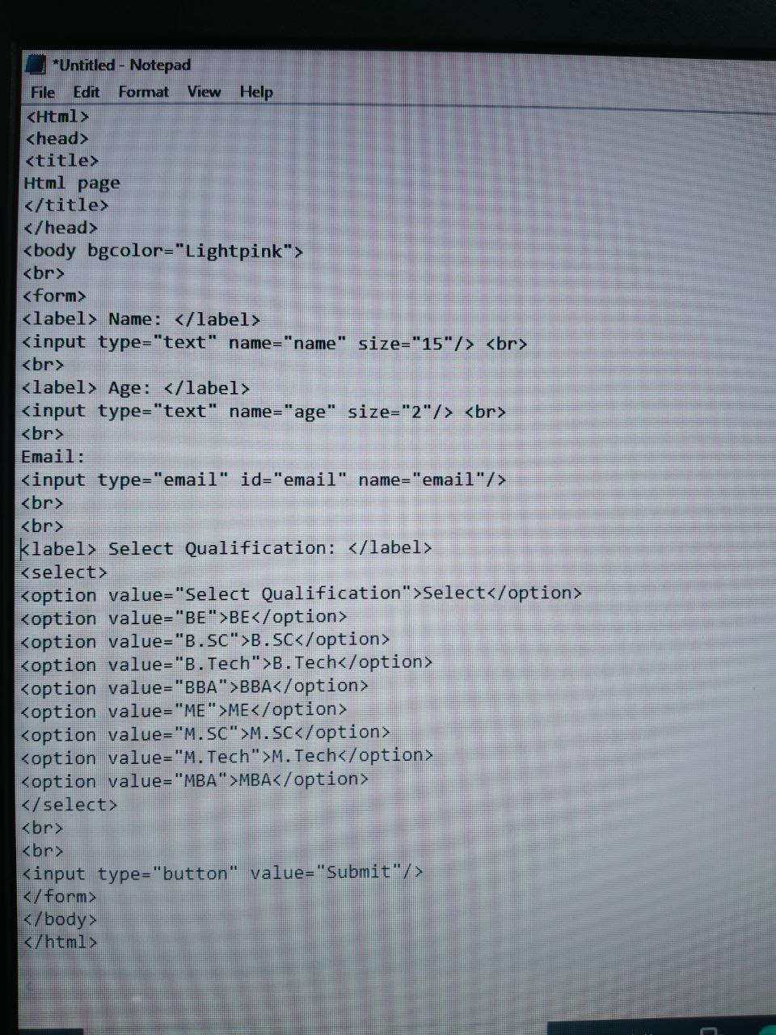

**OUTPUT:**

